(General Template for IATA case Studies - Building Blocks)
Title: Case Study on the use of Integrated Approaches for Testing and Assessment for “Target Endpoint(s)” of “Target Chemical(s)”
(N.B. The following template should not be viewed as a strict structure, but rather identifies the information that should be included in this type of case study. Depending on the specific case study additional information/(sub)section(s) may be required or particular subsections may not apply. The order of the (sub)sections of the template can be changed and two or more (sub)sections of the template can be merged, as necessary. The titles of a (sub) section can be changed as necessary. The template will be revised based on experience with use).
The overview document (OECD, 2020e) helps understanding of IATA, by explaining key concepts and providing basic definitions, and to support easier access to existing resources.
Abstract / Synopsis / Executive summary
This section should provide a brief overview of the case study, including the objectives, concepts, methodologies, outcomes and conclusion in about 300 words. Please refer to Executive Summary in Case Study 2018-1 (OECD, 2019a) and 2018-2 (OECD, 2019b), and Summary in 2017-3 (OECD, 2018a) as examples.
Table of Contents
Abbreviations and acronyms
1. Introduction
This should include a summary of the background/problem formulation, purpose, endpoints covered and description of the target chemical(s)/category, assessment approach.
2. Purpose
a. Purpose of use
Indicate the regulatory relevance (i.e. intended application) of the IATA. This may be: a)screening for priority setting in view of further evaluation; b) hazard identification/characterisation; c) risk assessment; d) other (please specify). If more than one purpose is possible, please specify the purpose as d) other. If the IATA is used for low toxicity prediction, please define what is meant by ‘low toxicity’ for the purposes of the particular case study.
If in a regulatory context, provide a short but sufficient description of any (e.g. legal) requirements for the IATA approach to be accepted.
b. Target chemical(s)
Provide the chemical descriptor common identifiers (including CAS number, name and composition including impurities [See 3.2.3.1 “Chemical identity and composition of the grouping guidance (OECD, 2014a)]) and chemical structure(s) of the target substance(s). In some case studies, target chemicals may be entire chemical classes or the IATA illustrated may be generic. Or if there are no specific target chemicals, example chemicals can be used to illustrate the IATA (SEE “1. PURPOSE” or “3. RESULTS OF ERC PRIORITISATION” of the case study 2017-2 (OECD, 2018b) and “1.2. Target Chemical(s)” at the section “1. Purpose” of the case study 2018-2 (OECD, 2019b)).
c. Endpoint(s)
Identify the endpoint(s) for which the IATA is applied.
d. Exposure information (if needed)
Provide the considered exposure, such as route of exposure (dermal, oral and inhalation), type of exposure (consumer, occupational and environment), for example, if the case study addresses prioritisation or chemical assessment work flows. The inclusion of this section and its level of detail/quantification will depend on the case study.
If relevant, please describe extrapolation from in vitro into in vivo.
Tip
- The description of the purpose of use is important for considering the acceptable uncertainty of the case study, which could be linked to the uncertainty assessment. For example, if the conclusion derived by case study is renewable in a framework such as tiered-approach, this needs to be clearly stated (see case studies OECD, 2016a and 2016b).
- As the goal of the OECD IATA Case Studies project is to discuss case studies which would lead to regulatory application a description of the regulatory relevance is important to contextualise the case and discuss the further development of guidance and how to use the IATA for regulatory purpose.

3. Hypothesis for performing IATA
- Provide the hypothesis for performing IATA for the identified purpose
- Describe how the IATA will be performed for the specific purpose.
- If many steps are included in the IATA, include a figure for the workflow of the IATA applied in the case study in order to provide an overview on how the IATA work through. Please refer to Figure 1 in Case Study 2019-4 (OECD, 2020a) and Figure 2 under section 4.1 “Testing and assessment strategy” in Case Study 2019-5 (OECD, 2020b). The below figure used in Case Study 2019-5 is an example.

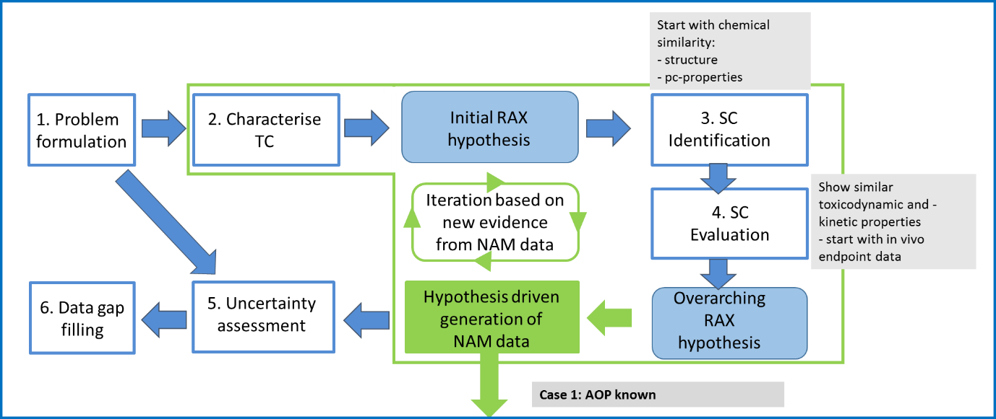
Example of Workflow Figure, which was used in Case Study 2019-5

4. Approaches used (Potential Blocks for Inclusion)
Describe which approaches are applied for assessing the chemicals under the provided hypothesis:
- AOP/MOA: Description of potential mechanism(s) for the target chemicals to induce target endpoint toxicity. In particular, the graphical representation of the AOP would be helpful for the reader and key references (See “Graphical Representation of the AOP” at section “1- AOP Description” of “User’s Handbook supplement to the Guidance Document for developing and assessing Adverse Outcome Pathways” (OECD, 2016e)). The tools in the AOP-KB should be referred to as appropriate (e.g. AOP wiki, Effectopedia etc.).
Identifying the relevant AOP from AOP wiki is required. Please provide the AOP number, status on AOP-wiki and the link. For AOPs that are not documented, consider the “Section 1-AOP Description” of "Users' Handbook supplement to the Guidance Document for developing and accessing Adverse Outcome Pathways" (OECD, 2016e) - although an entire AOP description is not the purpose here. If needed, the entire AOP can be described in Annex.
If an AOP together with testing of various MIE/KE/AO is used in the case study, a figure demonstrating the alignment of the AOP with the various tests should be included. Please refer to Figure 1 in Case Study 2018-2 (OECD, 2019b), Figure 3 in Case Study 2019-4 (OECD, 2020a), Figure 7 in Case Study 2019-5 (OECD, 2020b), Figure 2 (A and B) in Case study 2019-7 (OECD, 2020c) and Figure 5.1 (A and B) in Case Study 2019-8 (OECD, 2020d). The below figure is an example of the figure demonstrating the alignment of the AOP with the various tests, which was used in Case Study 2019-7. The figure indicated where the assay is available and not available.
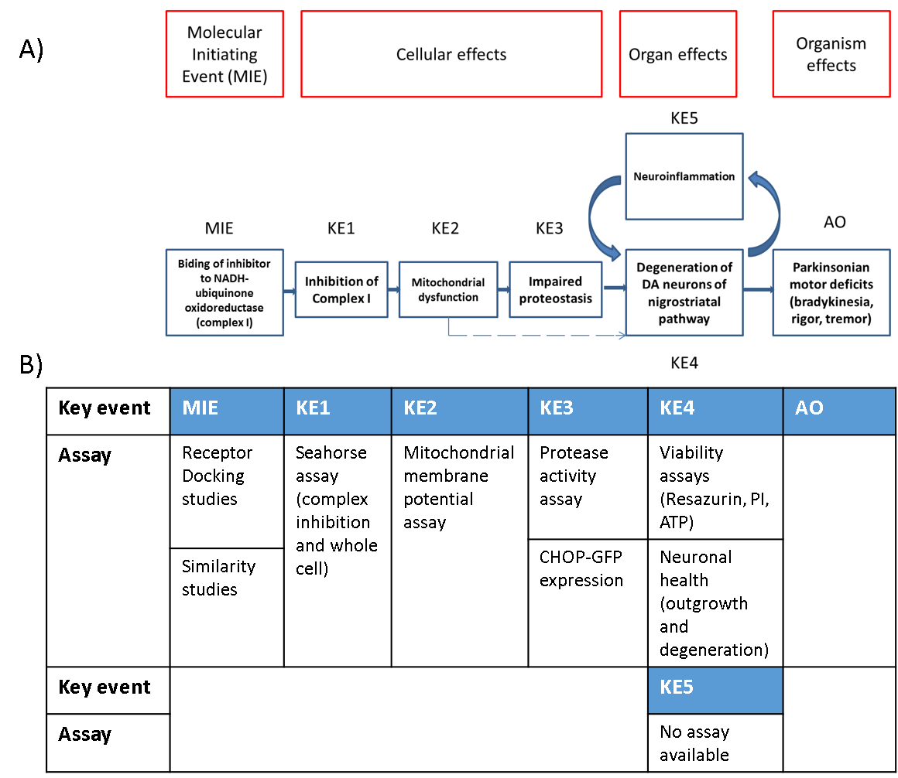
Example of AOP figure together with MIE/KE/AO, which was used in Case Study 2019-7

- Defined Approach: If a defined approach is included, please refer to the ANNEX I: TEMPLATE FOR REPORTING DEFINED APPROACHES TO TESTING AND ASSESSMENT BASED ON MULTIPLE INFORMATION SOURCES” of "Guidance Document on the Reporting of Defined Approaches to be used within Integrated Approaches to Testing and Assessment" (OECD, 2016c). Please copy into this section the “5. Rationale underlying the construction of the defined approach” from the above mentioned template (OECD, 2016c), completed with proper explanations. The elements described in the section “3. Approaches Used” of the case study 2018-2 (OECD, 2019b) can be helpful for development of an IATA using Defined Approach.
- Workflow: If an IATA workflow is included, provide a schematic and explanation of the elements of the workflow including input, decision and exit points. If prioritization is the goal of IATA workflow, provide an explanation of how to classify the hazard and exposure profiling and potential risk classification. Please refer to the section “CHEMICAL SAFETY ASSESSMENT WORKFLOW” of the case study 2016-5 (OECD, 2017), “3.3 IATA Workflow” of the case study 2017-1 (OECD, 2018c) , the section “2. PRIORITISATION OF CHEMICALS USING AN IATA-BASED ERC APPROACH” of the case study 2017-2 (OECD, 2018b) and “2. Hypothesis for performing IATA and Approaches used” of the case study 2020-1(OECD, 2021).
- Read-across: If a read-across is included, use elements of the template for IATA case studies on Read-Across or the grouping guidance (OECD, 2014a). Please refer to “4. Identification of analogues, suitability assessment and existing data” of the case study 2016-5 (OECD, 2017) and “4.1. Analogue chemicals” of the case study 2017-1 (OECD, 2018c)

5. Data/Information gathering
In this section, please describe the test methods or data sources used for gathering data for target chemicals
a. Data/Information
  - Provide the methods used for gathering the data for target chemical(s) (e.g. selection criteria of the data, data source).
- Provide the data gathered using appropriate reporting format. The levels details for reporting the data should be considered depending on the purpose of the IATA.
- If data from non-guideline test methods are included, provide descriptions of the methods or links to sources that summarise the methods. The appropriate degree of detail of the description should be considered in the context of the purpose of the case study. More detailed information on the methods can be included in an Annex. A template for the description is available in a OECD guidance document (OECD, 2014b). Examples of description using the template can be found in JRC EURL ECVAM Database service on Alternative Methods to animal experimentation (DB-ALM) and U.S. EPA Toxicity ForeCaster (ToxCast™) Data .
  - If QSAR data are included, provide the name, version, owner of the models used for deriving QSAR estimation data. If not already described elsewhere QSAR models should be reported using the QSAR Model Reporting Format (QMRF), and individual predictions, if applicable, should be reported using the QSAR Prediction Reporting Format (QPRF). A QMRF inventory is maintained by JRC that can be utilised as a resource of QMRFs and its reference number can be referred to JRC QSAR Model databases. QPRF(s) and QMRF should be included in Annex.
  - If the exposure elements are included, provide the methods used for the data generation (e.g. data source, exposure models/tools.). Please refer to “2. Identification of the use scenario of the case study 2016-5 (OECD, 2017)” and “Exposure profiling” of the case study 2017-2 (OECD, 2018b). If PBK models are included, please refer to OECD guidance (OECD, 2021b) of PBK which provide characterisation, Validation and Reporting of PBK models.
  - If a defined approach is included, please refer to the template of "Guidance Document on the Reporting of Defined Approaches to be used within Integrated Approaches to Testing and Assessment" (OECD, 2016c). In this section, please describe the individual information sources used and data interpretation procedure applied (See “6. Description of the individual information sources used (see Annex II)” and “7. Data interpretation procedure applied” of the OECD guidance (OECD, 2016c). Detailed information on the defined approaches can be included in the Annex. Please refer to the section “4. Data/Information Gathering” of the case study 2018-2 (OECD, 2019b).
  - If high throughput or omics data are used then indicate how the data has been applied in the specific case study ie to support in vivo/vitro data or any other reason etc.
- Provide justification/purpose for each assay/information used. Only necessary information should be provided, avoid giving information not directly useful for your Case Study (do not provide data just because you have it).

Please include a summary text box at the end of each subsection with the key highlights or conclusions of the subsection, which would impact on the conclusion, if authors believe this would help the readers. Summary text box applied in section “CHEMICAL SAFETY ASSESSMENT WORKFLOW PROPOSED” in Case Study 2016-5 can be referred (OECD, 2017)
b. Analogue chemicals.
  - If the data of analogue chemicals were used for the IATA, provide the selection criteria that were used to identify the analogue chemicals. This can be based on the hypothesis described in section 3.
  - Provide rational for selection of analogue(s) with respect to the defined purpose and endpoint.
  - Consider selection bias selecting analogue chemicals in relation to employment of the IATA (e.g. data completeness, support for hypothesis etc.).
  - Describe the methods used to identify the analogue chemicals (e.g. inventories and tools used should be provided). Listing search criteria to establish initial pool of candidate analogues is helpful.
  - Provide the common chemical identifiers (including CAS number, name and composition including impurities) and chemical structure(s) of the analogue chemicals.
  - Recommend to use positive and negative reference chemicals if possible, especially in the case of testing that is done to support the IATA.

6. Application of IATA

a. Summary of data
- Provide a summary of data in a suitable format for the purpose of IATA.
- Reliability of data should be discussed.
- The applicability domain of each estimation method including QSAR and alternative methods should be discussed.
- Provide analysis of the available information for suitability regarding the defined purpose. If possible, the available key study results should be indicated.

b. Application of IATA
- Describe how to apply IATA based on the hypothesis and the data gathered.
- Describe the result of IATA.
- Refine the hypothesis used, if necessary.

c. Uncertainty
- Discuss the uncertainty of each element of the IATA. We recommend to use a table to describe the uncertainty of each element. The following table provides an example of reporting uncertainty (Please modify as appropriate and also it is recommended to describe what is not addressed.) Also, you can refer the past case studies which the general template was applied. (Case Study 2017-2 (OECD, 2018b); Case Study 2018-2 (OECD, 2019b)). Aspects can include uncertainty and confidence associated with the data and assumptions used to develop hypothesis.
- The magnitude and impact of the sources of uncertainty should be considered and to the extent possible, how the individual sources of uncertainty affect the overall uncertainty in the final outcome of the IATA. OECD guidance documents on defined approaches of IATA (“ Consideration of uncertainties associated with the application of the defined approach”, OECD, 2016c; “ Consideration of uncertainties associated with the application of the defined approach”, CASE STUDY I-XII of OECD, 2016d) might be helpful for considering uncertainties related to non-guideline test methods. The uncertainty approaches outlined in the template for IATA case studies on Read-Across would be helpful for performing the uncertainty analysis.
- If AOP is used, please discuss uncertainty on AOP (e.g. endorsed AOP: the AOP approved and published by OECD vs putative AOP; the AOP not approved by OECD and established based on the known knowledge.)
- For the application of WoE approach, the ECHA WoE template provides a structured template for presenting the WoE approach/ uncertainty (EU-ToxRisk, 2018).
- The EFSA guidance documents (EFSA, 2018a; 2018b) could be considered for uncertainty assessment as a good start point. In addition, for quantitative hazard assessments, the WHO Guidance on Evaluating and Expressing Uncertainty in Hazard Assessment (WHO, 2018) can provide further support (EU-ToxRisk 2018).
- In application of WoE, please refer to the OECD WoE guidance document (OECD, 2019c), which provides universal Guiding Principles that should be considered when developing or augmenting systematic approaches to WoE for chemical evaluation and Key Elements to formulating a systematic approach to WoE.
Factor | Uncertainty  (low, medium, high) | Impact of uncertainty on hypothesis | Comment
Hypothesis
Used Approach (e.g. AOP/MOA, Defined Approach, workflow, read-across etc.)
Methods/assays used in the IATA
Data/information gathered in the IATA
Quality of the data/information used in the IATA
Concordance and weight of evidence of all data used for justifying the hypothesis
Overall uncertainty of the IATA

Tip
- When using ranks to indicate uncertainties (e.g. low, medium, high), definitions should be provided.
d. Strategy and integrated conclusion
- Describe the strategy used to develop the integrated conclusion.
- Discuss how/if to further address the uncertainties.
- Finally, provide a short conclusion wrapping up the outcome of the evaluation.

7. References
(See OECD style guide third edition, p.56 “Bibliographical referencing: Sources and citations”)
Annex
- Author can include supplemental or background data in an Annex in order to increase readability of case study if the data supports a particular aspect of the case study. The below table is an example of a summary table for in vivo data (Reference to Annex I and II in Case Study 2018-1 (OECD, 2019a); Annex IV in Case Study 2019-4 (OECD, 2020a)).

References
Species/strain
Sex
Route of admin.
Exposure period
Doses
GLP
Test substance
NOAEL
Result
Other findings

- Author can provide a summary of methods and tools used in the case study, that a regulator may be less familiar with, such as an in vitro method, in silico (QSAR) model or high throughput assay; or provide links to references of these methods for further information in order to increase readability of case study. The description should be sufficient for an expert, which a regulator may consult to get approval and better understanding of the methodology.

References
EFSA (2018a), Guidance on Uncertainty Analysis in Scientiﬁc Assessments, EFSA Journal 2018;16(1):5123, 39 pp. https://doi.org/10.2903/j.efsa.2018.5123
EFSA (2018b) Principles and methods behind EFSA’s Guidance on Uncertainty Analysis in Scientiﬁc Assessment. EFSA Journal 2018;16(1):5122, 282 pp. https://doi.org/10.2903/j.efsa.2018.5122
EU-ToxRisk (2018), Recommendations of the EU-ToxRisk Regulatory Advisory Board (RAB) on how to document case studies for regulatory evaluation
OECD (2014a), Guidance on Grouping of Chemicals, Second Edition, Series on Testing & Assessment No. 194, ENV/JM/MONO(2014)4, OECD, Paris.
OECD (2014b), Guidance Document for Describing Non-Guideline In Vitro Test Methods, Series on Testing and Assessment No. 211, ENV/JM/MONO(2014)35, OECD, Paris.
OECD (2016a), Case study on the Use of Integrated Approaches to Testing and Assessment for in vitro Mutagenicity of 3,3’ Dimethoxybenzidine (DMOB) Based Direct Dyes No. 251, ENV/JM/MONO(2016)49, OECD, Paris.
OECD (2016b), Case study on the Use of Integrated Approaches to Testing and Assessment for Repeated Dose Toxicity of Substituted Diphenylamines (SDPA) No. 252, ENV/JM/MONO(2016)50, OECD, Paris.
OECD (2016c), Guidance Document on the Reporting of Defined Approaches to Be Used within Integrated Approaches to Testing and Assessment No. 255, ENV/JM/MONO(2016)28, OECD, Paris.
OECD (2016d), Guidance Document on the Reporting of Defined Approaches and Individual Information Sources to Be Used within Integrated Approaches to Testing and Assessment (IATA) for Skin Sensitisation, Series on Testing and Assessment No. 256, ENV/JM/MONO(2016)29, OECD, Paris.
OECD (2016e), Guidance Document on the Reporting of Defined Approaches to Be Used within Integrated Approaches to Testing and Assessment No. 255, ENV/JM/MONO(2016)28, OECD, Paris.
OECD (2016f), “Users' Handbook supplement to the Guidance Document for developing and accessing Adverse Outcome Pathways”, OECD Series on Adverse Outcome Pathways, No. 1, OECD Publishing, Paris.
OECD (2017), Chemical Safety Assessment Workflow Based on Exposure Considerations and Non-animal Methods, Series on Testing and Assessment No. 275, ENV/JM/MONO(2017)27, OECD, Paris.
OECD (2018a), Case study on grouping and read-across for nanomaterials genotoxicity of nano-TiO2, Series on Testing and Assessment No. 292, ENV/JM/MONO(2018)28, OECD, Paris.
OECD (2018b), Prioritization of chemicals using the Integrated Approaches for Testing and Assessment (IATA)-based Ecological Risk Classification, Series on Testing and Assessment No. 291, ENV/JM/MONO(2018)27, OECD, Paris.
OECD (2018c), Case Study on the use of Integrated Approaches for Testing and Assessment (IATA) for Estrogenicity of the Substituted Phenols, Series on Testing and Assessment No. 290, ENV/JM/MONO(2018)26, OECD, Paris.
OECD (2019a), Case Study on the use of Integrated Approaches for Testing and Assessment for Testicular Toxicity of Ethylene Glycol Methyl Ether (EGME)-Related Chemicals, Series on Testing and Assessment No. 308, ENV/JM/MONO(2019)27, OECD, Paris.
OECD (2019b), Case Study on the Use of an Integrated Approach to Testing and Assessment for Identifying Estrogen Receptor Active Chemicals, Series on Testing and Assessment No. 311, ENV/JM/MONO(2019)31, OECD, Paris.
OECD (2019c), Guiding Principles and Key Elements for Establishing a Weight of Evidence for Chemical Assessment, Series on Testing and Assessment No. 311, ENV/JM/MONO(2019)31, OECD, Paris.
OECD (2020a), Case Study on the Use of Integrated Approaches for Testing and Assessment for Repeated-Dose Toxicity of p-Alkylphenols, Series on Testing and Assessment No. 323, ENV/JM/MONO(2020)19, OECD, Paris.
OECD (2020b), Prediction of a 90 day repeated dose toxicity study (OECD 408) for 2-Ethylbutyric acid using a read-across approach to other branched carboxylic acids, Series on Testing and Assessment No. 324, ENV/JM/MONO(2020)20, OECD, Paris.
OECD (2020c), Identification and characterization of parkinsonian hazard liability of deguelin by an AOP-based testing and read across approach, Series on Testing and Assessment No. 326, ENV/JM/MONO(2020)22, OECD, Paris.
OECD (2020d), Waiving of repeat-dose neurotoxicity study (TG 424) for azoxystrobin based on Read-Across to other strobilurins, Series on Testing and Assessment No. 327, ENV/JM/MONO(2020)23, OECD, Paris.
OECD (2020e), Overview of Concepts and Available Guidance related to Integrated Approaches to Testing and Assessment (IATA), Series on Testing and Assessment No. 329, OECD, Paris.
OECD (2021a), The use of Integrated Approaches for Testing and Assessment for the Systemic Toxicity of Phenoxyethanol when included at 1% in a body lotion, Series on Testing and Assessment No. XXX, ENV/JM/MONO(2021)XX, OECD, Paris.
OECD (2021b). Guidance Document on Characterisation, Validation and Reporting of PBK models for Regulatory Purposes, Series on Testing & Assessment No. XXX. ENV/JM/MONO(2021)XX, OECD, Paris.
WHO (2018), Guidance document on evaluating and expressing uncertainty in hazard haracterization, 2nd edition. https://apps.who.int/iris/handle/10665/259858

Appendix
Case Study No. | Case Study Title | Referred Information | Relevant template section | Why this example works well
2017-3 | Case study on grouping and read-across for nanomaterials genotoxicity of nano-TiO₂ | SUMMARY, Page 8 | Abstract / Synopsis / Executive summary | This summary is concise and includes the elements described in this template.
2018-1 | Case Study on the use of Integrated Approaches for Testing and Assessment for Testicular Toxicity of Ethylene Glycol Methyl Ether (EGME)-Related Chemicals | Executive Summary, Page 7 | Abstract / Synopsis / Executive summary | This summary is concise and includes the elements described in this template.
2018-2 | Case Study on the Use of an Integrated Approach to Testing and Assessment for Identifying Estrogen Receptor Active Chemicals | Executive Summary, Page 7 | Abstract / Synopsis / Executive summary | This summary is concise and includes the elements described in this template.
2017-2 | Prioritization of chemicals using the Integrated Approaches for Testing and Assessment (IATA)-based Ecological Risk Classification | 1. PURPOSE, Page 12 | 2. Purpose: target chemical | The section includes a clear and concise description of the target chemicals that 640 organic substances were evaluated based on the IATA and that the results of 3 chemicals were showed as example.
2018-2 | Case Study on the Use of an Integrated Approach to Testing and Assessment for Identifying Estrogen Receptor Active Chemicals | 1.2. Target Chemical, Page 13 | 2. Purpose: target chemical | The section includes a clear and concise description of the target chemicals that there are no specific target chemicals.
2015-1 | In Vitro Mutagenicity of 3,3’ Dimethoxybenzidine (DMOB) Based Direct Dyes | 1.1. Purpose of use, Page 10 | 2. Purpose; Purpose of use | The section provides a clear and concise overview of the purpose of use including the regulatory purpose. This helps the readers understand how much extent of the uncertainty is acceptable in the case study, which could be linked to the uncertainty assessment.
2015-2 | Repeat Dose Toxicity of Substituted Diphenylamines (SDPA) | 1.1. Purpose of use, Page 9 | 2. Purpose; Purpose of use | The section provides a clear and concise overview of the purpose of use including the regulatory purpose. This helps the readers understand how much extent of the uncertainty is acceptable in the case study, which could be linked to the uncertainty assessment.
2019-4 | Case Study on the Use of Integrated Approaches for Testing and Assessment for Repeated-Dose Toxicity of p-Alkylphenols | Read-across workflow in this case study, Fig.1 | 3. Hypothesis for performing IATA; Figure for a Workflow | The figure provide a clear and concise workflow in this case study, which helps to guide the reader through.
2019-5 | Prediction of a 90 day repeated dose toxicity study (OECD 408) for 2-Ethylbutyric acid using a read-across approach to other branched carboxylic acids | Overview of the six traditional assessment steps within the read-across assessment, Fig.2 | 3. Hypothesis for performing IATA; Figure for a Workflow | The figure provide a clear and concise workflow in this case study, which helps to guide the reader through.
2020-1 | use of Integrated Approaches for Testing and Assessment for the Systemic Toxicity of Phenoxyethanol when included at 1% in a body lotion | IATA workflow, Fig. 1 | 3. Hypothesis for performing IATA; Figure for a Workflow | The figure provide a clear and concise workflow in this case study, which helps to guide the reader through.
2018-2 | Case Study on the Use of an Integrated Approach to Testing and Assessment for Identifying Estrogen Receptor Active Chemicals | Representation of the ER pathway and computational model, Fig.1, Page 16 | 4. Approaches Used; AOP | The figure provides a clear and concise overview of the putative AOP along with testing for MIE/KE/AO applied in the case study, which helps to guide the reader through.
2019-4 | Case Study on the Use of Integrated Approaches for Testing and Assessment for Repeated-Dose Toxicity of p-Alkylphenols | Overview of hepatotoxic mechanism of p-alkylphenols, Fig.3 | 4. Approaches Used; AOP | The figure provides a clear and concise overview of the putative AOP along with testing for MIE/KE/AO applied in the case study, which helps to guide the reader through.
2019-5 | Prediction of a 90 day repeated dose toxicity study (OECD 408) for 2-Ethylbutyric acid using a read-across approach to other branched carboxylic acids | Overview on test systems used for hazard characterization, Fig.7 | 4. Approaches Used; AOP | The figure provides a clear and concise overview of the putative AOP along with testing for MIE/KE/AO applied in the case study, which helps to guide the reader through.
2019-7 | Identification and characterization of parkinsonian hazard liability of deguelin by an AOP-based testing and read across approach | AOP on inhibition of the mitochondrial complex I of nigrostriatal neurons leading to parkinsonian motor deficits, Fig.2 | 4. Approaches Used; AOP | The figure provides a clear and concise overview of the endorsed AOP along with testing for MIE/KE/AO applied in the case study, which helps to guide the reader through.
2019-8 | Waiving of repeat-dose neurotoxicity study (TG 424) for azoxystrobin based on Read-Across to other strobilurins | AOP on the inhibition of mitochondrial complex III leading to neurotoxic effects, Fig.5.1 | 4. Approaches Used; AOP | The figure provides a clear and concise overview of the putative AOP along with testing for MIE/KE/AO applied in the case study, which helps to guide the reader through.
2018-2 | Case Study on the Use of an Integrated Approach to Testing and Assessment for Identifying Estrogen Receptor Active Chemicals | 3. Approaches Used, Page 15-16 | 4. Approaches Used; Defined approach | The description provides the hypothesis including element of defined approach.
2016-5 | Chemical Safety Assessment Workflow Based on Exposure Considerations and Non-animal Methods | Schema of the chemical safety  assessment workflow, Fig. 1, Page 11 | 4. Approaches Used; Workflow | The workflow presented in this figure provides a clear and concise overview of the case study, which helps to guide the reader through.
2017-1 | Estrogenicity of Substituted Phenols | IATA workflow, Fig. 3, Page 22 | 4. Approaches Used; Workflow | The workflow presented in this figure provides a clear and concise overview of the case study, which helps to guide the reader through.
2017-2 | Prioritization of chemicals using the Integrated Approaches for Testing and Assessment (IATA)-based Ecological Risk Classification | Framework for the ecological risk classification, Fig.1, Page 15 | 4. Approaches Used; Workflow | The framework presented in this figure provides a clear and concise overview of the case study, which helps to guide the reader through.
2016-5 | Chemical Safety Assessment Workflow Based on Exposure Considerations and Non-animal Methods | 4. Identification of analogues, suitability assessment and existing data, Page 13-14 | 4. Approaches Used; Read-across | This section describes the possibility for utility of read-across approach as one of the components in the case study.
2017-1 | Estrogenicity of Substituted Phenols | 4.1. Analogue chemicals, Page 26-33 | 4. Approaches Used; Read-across | The section provides a clear and concise overview of approaches to select analogues with figures and tables in the workflow case study.
2016-5 | Chemical Safety Assessment Workflow Based on Exposure Considerations and Non-animal Methods | TIER 0: Identification of the use scenario, chemical of  interest and collection of existing information; use scenario, Page 11 | 5. Data/Information gathering; Exposure | This subsection describes the exposure scenario applied in the IATA such as use product, concentration and exposure route.
2017-2 | Prioritization of chemicals using the Integrated Approaches for Testing and Assessment (IATA)-based Ecological Risk Classification | 2.2. Hazard and exposure profiling in the ERC approach, Exposure profiling, Page 20-21 | 5. Data/Information gathering; Exposure | This subsection describes how exposure profiling was determined, and provides the information on data source.
2018-2 | Case Study on the Use of an Integrated Approach to Testing and Assessment for Identifying Estrogen Receptor Active Chemicals | 4. Data/Information Gathering, Page 17-24 | 5. Data/Information gathering; Defined Approach | This section describes an integrated battery of in vitro assays and a computational model with figures and tables, which provide an overview of data/information gathering procedure.
2016-5 | Chemical Safety Assessment Workflow Based on Exposure Considerations and Non-animal Methods | CHEMICAL SAFETY ASSESSMENT WORKFLOW PROPOSED, Page 11-24 | 5. Data/Information gathering; Summary text box | The summary textboxes provides a conclusion under each section, which makes readers understand what conclusion is observed.
2017-2 | Prioritization of chemicals using the Integrated Approaches for Testing and Assessment (IATA)-based Ecological Risk Classification | 3.3. Uncertainties identified in the ERC approach, Table 5, Page 34-35 | 6. Application of IATA; Uncertainty | This uncertainty table provides an overview of the uncertainty analysis for each element associated with the IATA-based prioritisation.
2018-2 | Case Study on the Use of an Integrated Approach to Testing and Assessment for Identifying Estrogen Receptor Active Chemicals | 5.4. Uncertainty, Table 5, Page 34-35 | 6. Application of IATA; Uncertainty | This uncertainty table provides an overview of the uncertainty analysis for each element associated with the IATA-based prioritisation.
2018-1 | Case Study on the use of Integrated Approaches for Testing and Assessment for Testicular Toxicity of Ethylene Glycol Methyl Ether (EGME)-Related Chemicals | Annex I and Annex II. Page 35-59, | Annex: A summary table for in vivo data | The summary table provides a robust summary for in vivo assay.
2019-4 | Case Study on the Use of Integrated Approaches for Testing and Assessment for Repeated-Dose Toxicity of p-Alkylphenols | Annex IV | Annex: A summary table for in vivo data | The summary table provides a robust summary for in vivo assay.

AOP-KB. https://aopkb.oecd.org/
AOP Wiki. https://aopwiki.org/
Effectopedia. https://www.effectopedia.org/
JRC, EURL ECVAM Database service on Alternative Methods to animal experimentation (DB-ALM). https://ecvam-dbalm.jrc.ec.europa.eu/.
U.S. EPA, Toxicity ForeCaster (ToxCast™) Data https://www.epa.gov/chemical-research/toxicity-forecaster-toxcasttm-data
QMRF is available: https://community.oecd.org/docs/DOC-144256
QPRF is available: https://community.oecd.org/docs/DOC-144257
JRC, QSAR Model Database. https://qsardb.jrc.ec.europa.eu/qmrf/
ECHA – Template for Weight of Evidence / Uncertainty in Hazard Assessment https://echa.europa.eu/documents/10162//17169198/template_for_weight_of_evidence_en.docx

